ALLEN 8005571.05 Oil Level sensor

REVISION HISTORY
REV | ECO | DATE
A | ADCN 01894 | 10/22/2021
B | ADCN 01993 | 3/9/2022
C | ADCN 02091 | 8/4/2022
D | ADCN 02339 | 06/21/2023
E | ADCN 02429 | 09/11/2023
F | ECO 24063 | 9/9/2025

- Introduction:
The following procedure sets forth the method for conducting acceptance tests on production units of the Allen 8005571.05 (P&WC 30Y0241-01) Oil Level Sensor. Each Oil Level Sensor shall be subjected to and meet the requirements of this document before being accepted for use.
  - Reference Documents:
NOTE: Latest Revision to be used unless otherwise specified
Equipment Specification ES 3582 Sensor – Oil Level
General Specification ES 2968
  - Acronyms:
SO Shipping Order
SA INSP Sub-Assembly Inspection
FA INSP Final-Assembly Inspection
- Equipment Required:
NOTE: Equivalent substitutes may be used provided the equipment has the same or better accuracies.
- 0-8.8 Lb Scale, Accuracy > ± .005 Lbs.
- Oil Level Test Sump TU-002-V4 or TU-002-V5
- Misc. Shut Off Valves and Plumbing Supplies
- Hypot III Dielectric Withstand Tester, Associated Research, Inc., Model #3770, Accuracy within 2% of Setting, Allen ID No. 9631887
- Micro-ohmmeter, AEMC Instruments Model 6240, Allen ID No. 112537SBDV
- Analog Laser Sensor, Keyence, IL-600, LK-503, or LK-G507 (Linearity ±0.25% of Full Scale)
- Test Fixture T-20079
- 0-500 PSI Pressure Gage, Accuracy: ±0.1% of Reading

- Test Conditions:
  - Cleaning:
Prior to testing the unit, all parts normally in contact with the fluid use in service shall be thoroughly cleaned to remove all foreign matter.
  - Test Fluid(s):
MIL-PRF-7808 or MIL-PRF-23699
  - Temperature:
Ambient and Test Fluid: 60° to 100° F.
  - Test Facilities:
Testing required in this Acceptance Test Procedure shall be conducted at the following location:
Allen Aircraft Products, Inc.
6168 Woodbine Avenue
Ravenna, OH 44266
Phone: (330) 296-9621
- 8005571.05-SA Assembly Instructions Procedure, Step 30.1.1:
Record the resistance between the Channel A Orange wire and Black wire on the Data Card. Resistance shall be 2100± 21 ohms. Record the resistance between the Channel B Red wire and Yellow wire on the Data Card. Resistance shall be 2100± 21 ohms.
- 8005571.05 Oil Level Sensor Procedure:
  - Examination of Product: Sample 100%
Examine each unit to determine conformance with Allen Drawing 8005571.05 with respect to design, dimensions, materials, finishes, workmanship, and any other requirements for which there are no specific functional tests. Examine the part marking to determine the conformance with Allen Process Drawing 402562.70. The Oil Level Sensor float shall move back and forth freely with no binding or sticking. Record "OK" on Data Card if unit is acceptable.

  - Weight: Sample 100%
Weigh dry, completed unit including markings, coatings, etc. in accordance with above sampling plan. Unit weight shall not exceed .82 lb. Record actual weight on Data Card.
  - Insulation Resistance: Sample 100%
Connect pins 2, 3, 4, & 5 to the positive supply from the Dielectric Withstand Tester. Connect the ground to the flange of the Oil Level Sensor. See Figure 1 and Figure 2 for test setup. Raise the voltage to 475-525 VDC and record the resistance reading. The minimum resistance shall be 40 megaohms. Lower the voltage to zero. Record resistance on Data Card.
Connect pins 2 & 3 to the positive supply from the Dielectric Withstand Tester and ground pins 4 & 5 as shown in Figure 7 and Figure 8. Raise the voltage to 475-525 VDC and record the resistance reading. The minimum resistance shall be 40 megohms. Lower the voltage to zero. Record resistance on Data Card.
  - Dielectric Strength: Sample 100%
*If any reruns of the dielectric strength test are required, these tests shall be run at 80% voltage (859 volts RMS).
    - Pins To Flange
Connect pins 2, 3, 4, & 5 to the AC Outlet of the Dielectric Withstand Tester and ground the flange of the Oil Level Sensor, as shown in Figure 1 and Figure 2. Raise the voltage at a uniform rate of 250 to 500 volts per second to 1073* volts RMS minimum at 60 Hz. Maintain the voltage at 1073* volts RMS minimum for a minimum of one second and then lower the voltage at a uniform rate of 250 to 500 volts per second. Any arcing as evidenced by flashover, sparkover, breakdown or leakage current exceeding 2 milliamperes, shall constitute failure of the test.
    - Channel To Channel
Connect pins 2 & 3 to the AC Outlet of the Dielectric Withstand Tester and ground pins 4 & 5 as shown in Figure 7 and Figure 8. Raise the voltage at a uniform rate of 250 to 500 volts per second to 1073* volts RMS minimum at 60 Hz. Maintain the voltage at 1073* volts RMS minimum for a minimum of one second and then lower the voltage at a uniform rate of 250 to 500 volts per second. Any arcing as evidenced by flashover, sparkover, breakdown or leakage current exceeding 2 milliamperes, shall constitute failure of the test. Record "OK" on Data Card if unit is acceptable.
  - Bonding Resistance: Sample 100%
Connect one lead of the Digital Multimeter to the connector shell. Connect the other lead to the bottom side of the mounting flange (Datum A on drawing 8005571.05). See Figure 3 and Figure 4 for test setup. Measure and record the bonding resistance on the data card. The bonding resistance between the connector shell and mounting flange shall not exceed 10 milliohms.
  - Fluid Level: Sample 100%
Install the Oil level Sensor into the Oil Level Test Sump TU-002-V5 as shown in Figure 5. Attach the harness and -10, 6 socket connector plug from the Data Acquisition Unit (DATAQ) as shown in Figure 5. The test circuitry and cable lead connections are as shown in Figure 5A. The test shall be set up to continuously record at a sampling rate of 20 Hz. Resistance is to be measured between the Signal (Pin 2) and Return (Pin 3) of Circuit A and between the Signal (Pin 5) and Return (Pin 4) of Circuit B. The Keyence Laser will measure the Oil Level. The required Test Resistance range and Oil Levels for the 8005571.05 Oil Level Sensor for Circuit A and Circuit B are provided in Tables 1 and 2, respectively.
Note: Fluid level ATP testing is performed at room temperature.
- Start up the Oil Level Test Program for the P&WC Elevate 8005571.05 Oil Level Sensor.
- Enter the Job Routing Number to set up the output file.
- Enter the Unit Number of the test unit being tested and complete the remaining prompts (Allen Quality Assurance will replace the Unit Numbers with Serial Numbers after acceptance testing is complete).
- Verify the Program is correct and ready to proceed and Click START to begin the test.
The program will begin with a pre-drain, if required, to an oil level of 8.40” from the mounting flange to begin the test. The Test will begin with Fill from 8.40” (Circuit A and B resistance should be at 100 ±2 Ohms) and continue up to 2.60”. The program will monitor and record the Circuit A and B Resistances during the fill, as well as record the levels at the upper end of the oil traveling range for each level (just inside the minimum dimensional tolerance band). if the reed switch activates prior to the extreme minimum tolerance and the Resistance is within the required tolerance, the Fill Status Block will turn Green. If the two conditions are not met, the Block will turn Red, which indicates a failure.
Once the Oil Level reaches 2.60”, the program will begin the Drain process The program will monitor and record the Circuit A and B Resistances during the draining as well as record the levels at the lower end of the oil traveling range for each level (just inside the maximum dimensional tolerance band). if the reed switch activates prior to the extreme maximum tolerance and the Resistance is within the required tolerance, the Drain Status Block will turn Green. If the two conditions are not met, the Block will turn Red, which indicates a failure.
At the conclusion of the test, the Test Data will be available to review and save to the to a folder identified by the JOL Number.
Record “OK” for accept or “FAIL” for reject on the ATP Data Sheet for Requirement ‘5.6 Fluid Levels’ based on meeting the Table 1 and Table 2 requirements for oil level and resistance. Print out the Test Data Sheet to accompany the ATP Data Sheet for each test unit. See Table 3 for a sample and the Oil Switching Levels Test Data Sheet.
  - Proof Pressure: Sample 100%
Install Oil Level Sensor into Fixture T-20079 as shown in Figure 6. Apply 103 PSI with hand pump. Close shut off valve. After 1 minute there shall be no decrease in pressure. Open the shut off valve, reduce pressure, and remove Oil Level Sensor from test fixture. Record “0” on data sheet if unit is acceptable.
Note: The Oil Level Sensor has a proof pressure of 80 PSI and a short time maximum temperature of 335°F. Because this test will be performed at ambient lab conditions, the test pressure has been increased to compensate for the reduced material yield strength at 335°F. According to MMPDS-10, the yield strength of 6061-T651 Aluminum is 78% of its ambient temperature yield strength (see Figure 9). To calculate the compensated proof pressure requirement, the following equation is used.

$${Proof Pressure}_{Comp}= \frac{{Proof Pressure}_{Amb}}{{\% Yield Strength}_{Op. Temp}}=\frac{80 PSI}{78\%}=102.56 PSI$$

Switch Location | Oil Rising |  | Oil Draining
 | Oil Level from Mounting Surface Set Point  (inches) | Resistance Requirement (Ohms) | Oil Level from Mounting Surface Set Point  (inches) | Resistance Requirement (Ohms)
1A | 7.910-8.010 | 100 ±2 | 7.550-7.650 | 100 ±2
2A | 7.460-7.560 | 200 ±3 | 7.100-7.200 | 200 ±3
3A | 7.010-7.110 | 300 ±4 | 6.650-6.750 | 300 ±4
4A | 6.560-6.660 | 400 ±5 | 6.200-6.300 | 400 ±5
5A | 6.110-6.210 | 500 ±6 | 5.750-5.850 | 500 ±6
6A | 5.660-5.760 | 600 ±7 | 5.300-5.400 | 600 ±7
7A | 5.210-5.310 | 700 ±8 | 4.850-4.950 | 700 ±8
8A | 4.760-4.860 | 800 ±9 | 4.400-4.500 | 800 ±9
9A | 4.310-4.410 | 900 ±10 | 3.950-4.050 | 900 ±10
10A | 3.860-3.960 | 1000 ±11 | 3.500-3.600 | 1000 ±11
11A+12A | 3.410-3.510 | 1100 ±12 | 3.050-3.150 | 1100 ±12
TABLE 1
Oil Switching Levels - Circuit A Switches

Switch Location | Oil Rising |  | Oil Draining
 | Oil Level from Mounting Surface Set Point  (inches) | Resistance Requirement (Ohms) | Oil Level from Mounting Surface Set Point  (inches) | Resistance Requirement (Ohms)
1B+2B | 7.685-7.785 | 100 ±2 | 7.325-7.425 | 100 ±2
3B | 7.235-7.335 | 200 ±3 | 6.875-6.975 | 200 ±3
4B | 6.785-6.885 | 300 ±4 | 6.425-6.525 | 300 ±4
5B | 6.335-6.435 | 400 ±5 | 5.975-6.075 | 400 ±5
6B | 5.885-5.985 | 500 ±6 | 5.525-5.625 | 500 ±6
7B | 5.435-5.535 | 600 ±7 | 5.075-5.175 | 600 ±7
8B | 4.985-5.085 | 700 ±8 | 4.625-4.725 | 700 ±8
9B | 4.535-4.635 | 800 ±9 | 4.175-4.275 | 800 ±9
10B | 4.085-4.185 | 900 ±10 | 3.725-3.825 | 900 ±10
11B | 3.635-3.735 | 1000 ±11 | 3.275-3.375 | 1000 ±11
12B | 3.185-3.285 | 1100 ±12 | 2.825-2.925 | 1100 ±12

TABLE 2
Oil Switching Levels - Circuit B Switches

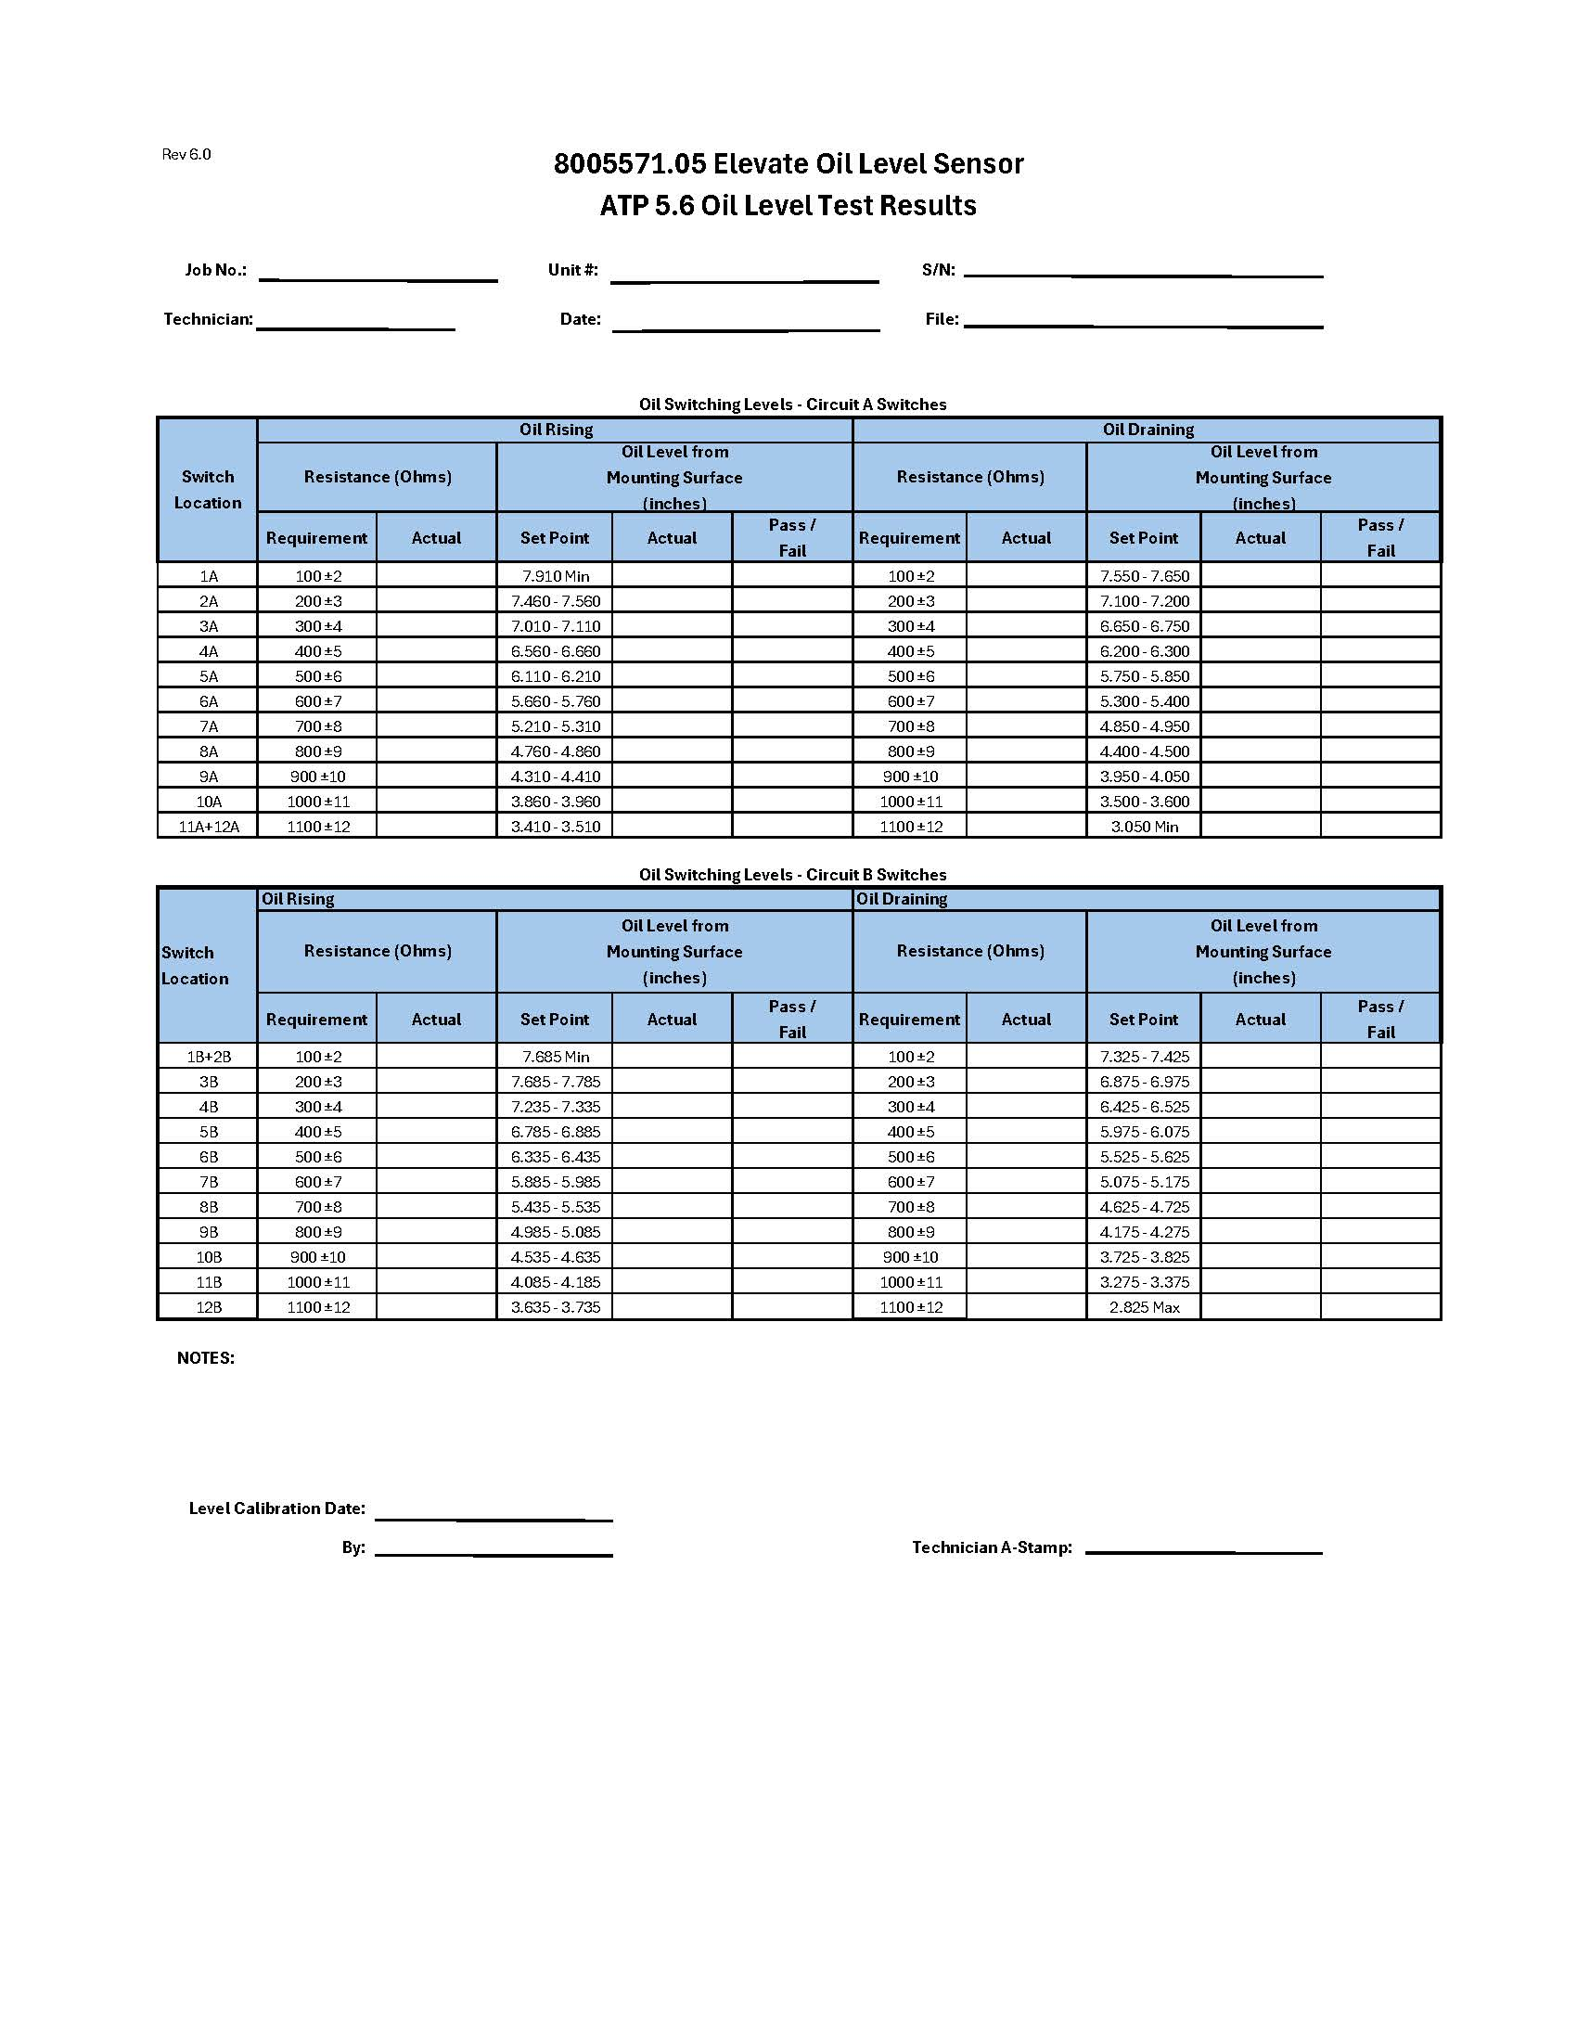
TABLE 3
Automated ATP Fluid Level Test Data Sheet

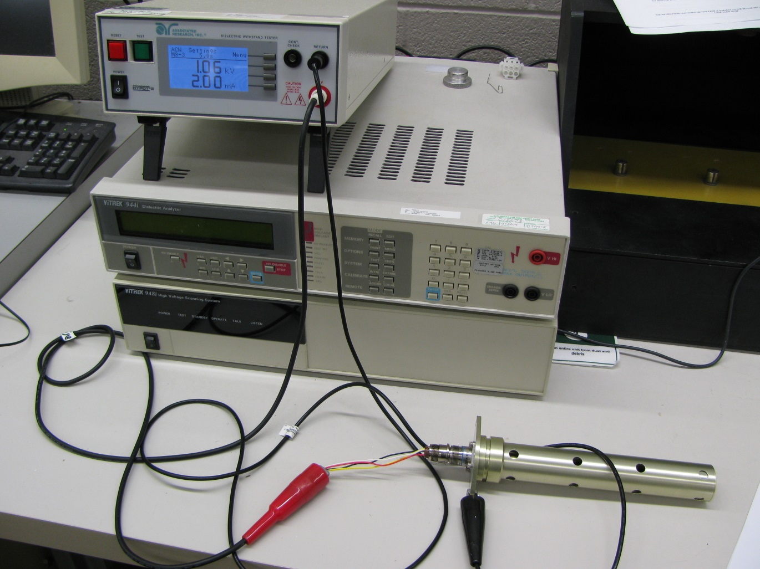

FIGURE 1
Dielectric Strength and Insulation Resistance Test Setup

Return Output Terminal
High Voltage Output Terminal

Alligator clamp to mounting surface, Datum A on 8005571.05

-10, 6 pin, mating plug or equivalent

FIGURE 2
Dielectric Strength and Insulation Resistance Setup Schematic

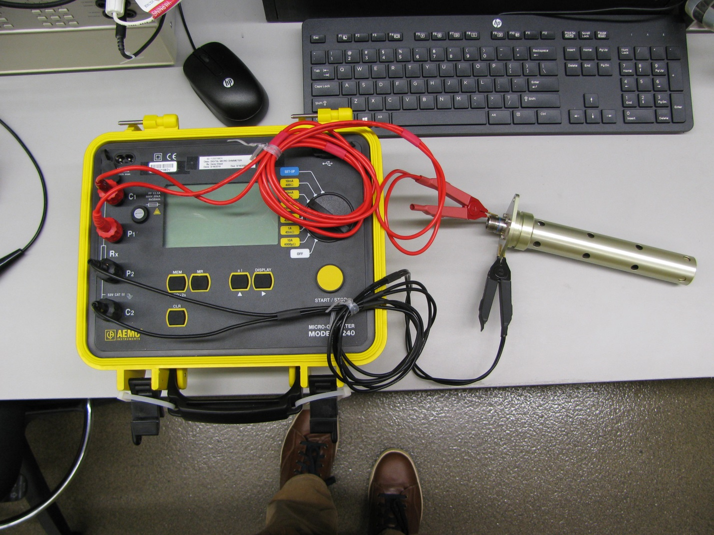

FIGURE 3
Bonding Resistance Test Setup

Alligator clamp to connector shell

Alligator clamp to mounting surface, Datum A on 8005571.05

FIGURE 4
Bonding Resistance Setup Schematic

FIGURE 5
Oil Level Functional Test Setup

FIGURE 5A
8005571.05 Cable Lead Connections

FIGURE 6
Proof Pressure Test Setup

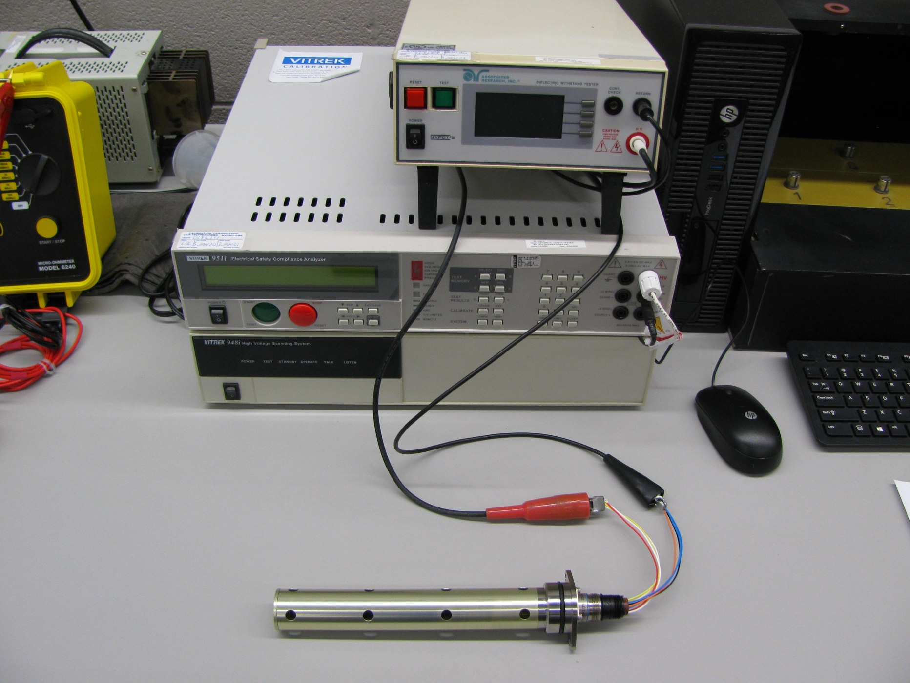

FIGURE 7
Dielectric Strength and Insulation Resistance Test Setup

Return Output Terminal
Alligator clamp to pins 2 & 3.
High Voltage Output Terminal

Alligator clamp to pins 4 & 5.

-10, 6 pin, mating plug

FIGURE 8
Dielectric Strength and Insulation Resistance Setup Schematic

FIGURE 9
Yield Strength Reduction (Figure 3.6.2.2.1(b) from MMPDS-10)

